Lesson 5 Demo 8: Demonstrate Locking in a Swarm Cluster

This section will guide you to:

* Lock and unlock the swarm cluster in Docker

**Step 1:** On the master tab, use the following command to enable *auto-locking* on the existing swarm cluster

*sudo docker swarm update --autolock=true*

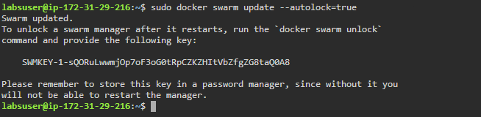

**Note:** Make sure you copy the unlock-key and save it for later use.

**Step 2:** Restart the docker daemon to check whether the swarm cluster is locked

*sudo systemctl docker restart*

*sudo docker service ls*

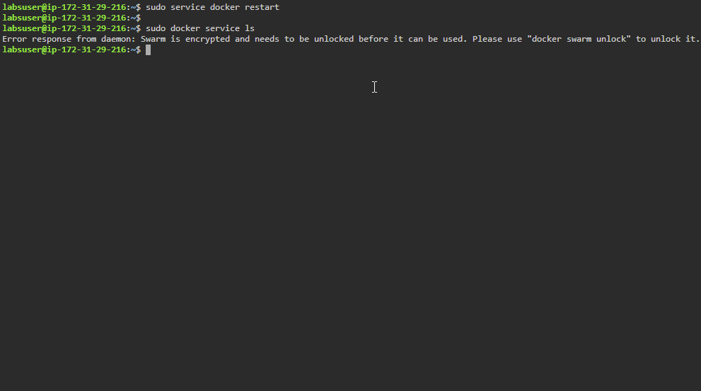

**Step 3:** Unlock the swarm cluster using the **unlock-key** saved in first step

*sudo docker swarm unlock*



**Note:** To enter the unlock key, copy the key to the clipboard and paste in using **Ctrl+Shift+V.**

**Step 4:** Use the following command to view the current unlock key

*sudo docker swarm unlock-key*

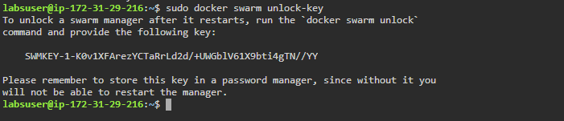

**Step 5:** Use the following command to rotate the unlock key

*sudo docker swarm unlock-key --rotate*

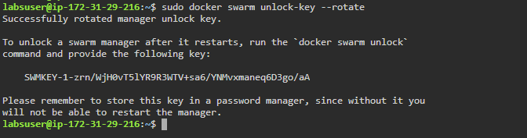

**Note:** It is advisable to rotate the locked swarm’s unlock key on a regular schedule. Make sure you keep a record of the unlock-key to unlock the swarm cluster.

**Step 6:** To disable *auto-locking* on the existing swarm cluster, use the following command:

*sudo docker swarm update --autolock=false*

